

Cyber Security

CS_TALAKUNCHI NETWORKS BATCH 2



Name :- Ojus P. Jaiswal

**Internship Project 2**

**Exploiting Server Vulnerabilities**

**Task 1 :-**Check for SMTP Open Relay

**Solution :-**

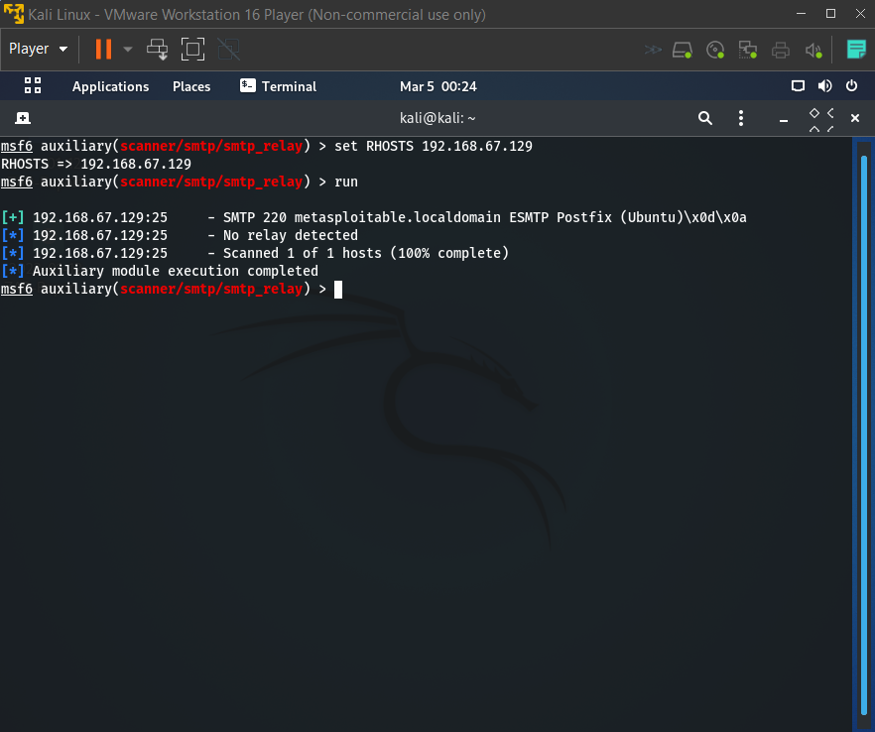

**Task 2 :-** Check for Zone Transfers

**Solution :-**

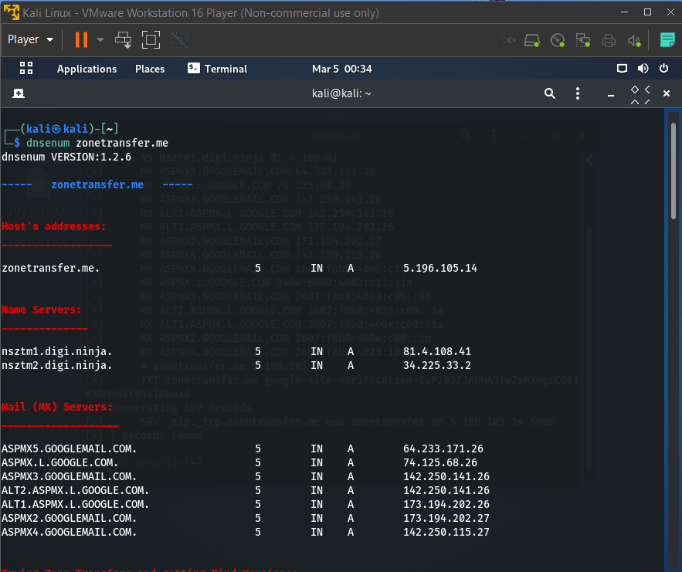

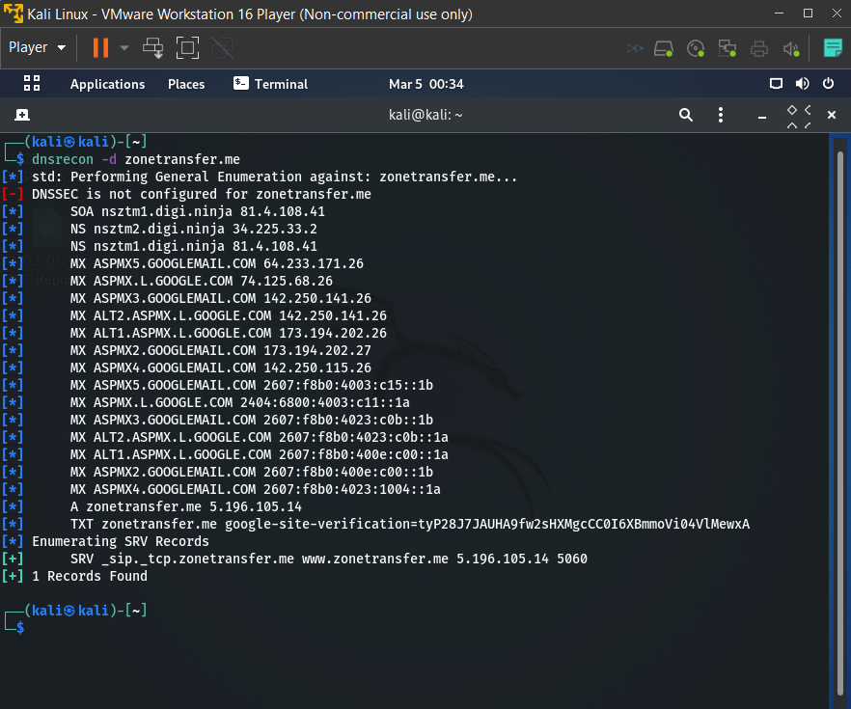

**Task 3 :-**Perform NetBIOS Enumeration

**Solution :-**

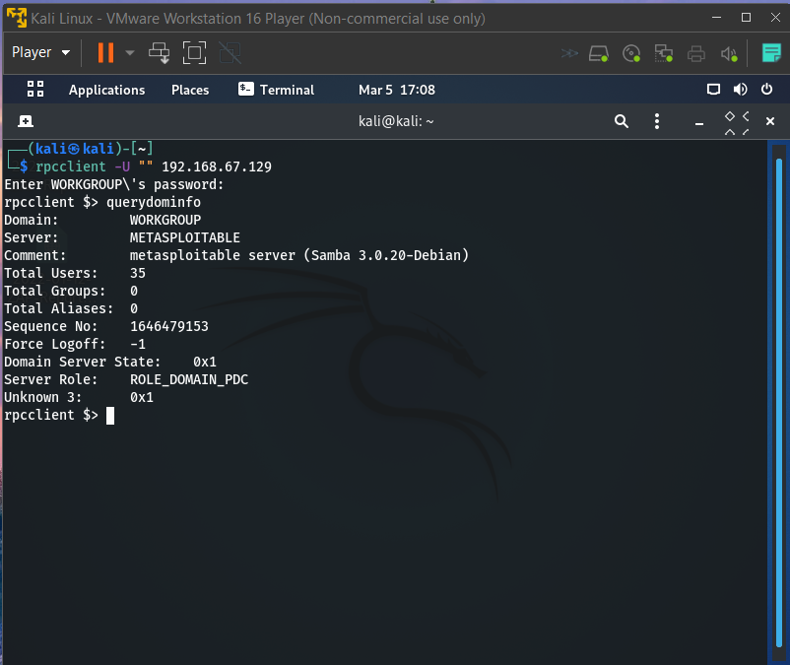

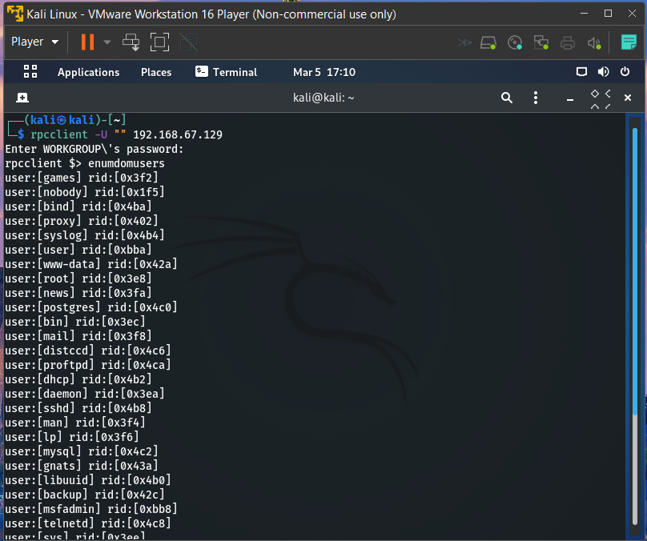

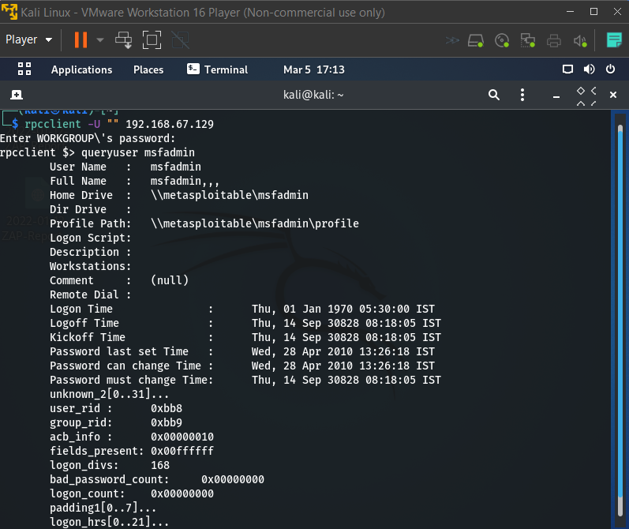

**Task 4 :-**Sniff the data of any application using Wire-Shark

**Solution :-**

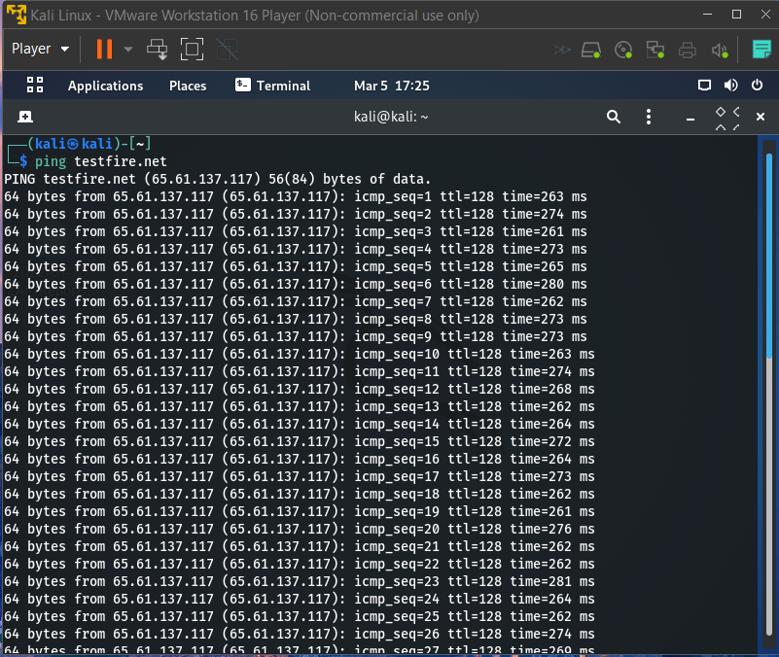

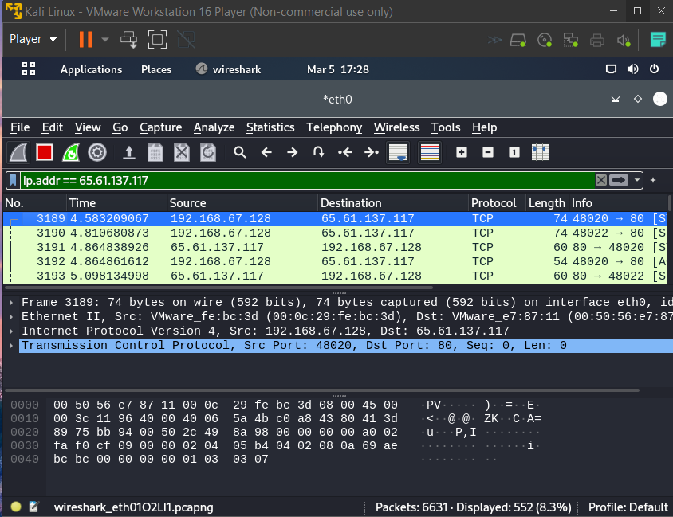

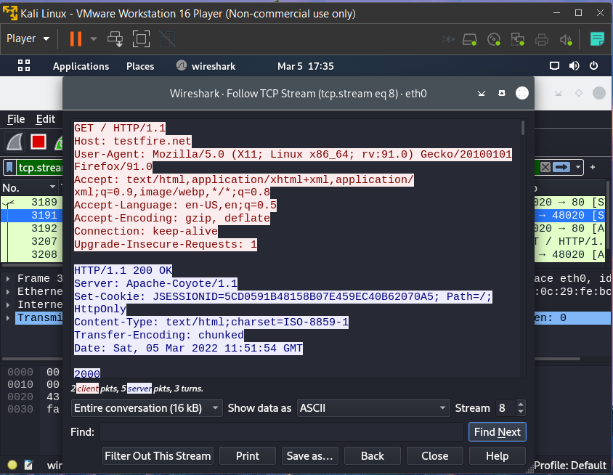

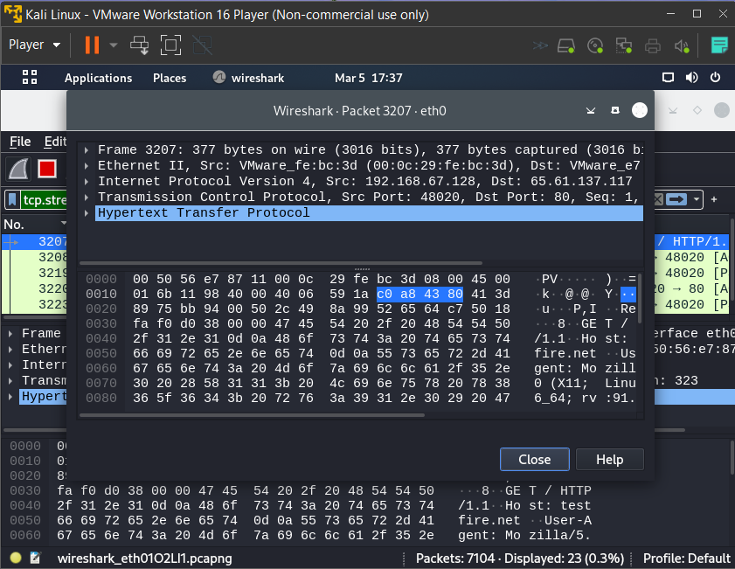

**Task 5 :-**Perform DOS Attack using Metasploit framework

**Solution :-**

